# Project Report

On

**PARTICLE SWARM OPTIMIZATION-BASED PID** **CONTROLLER**

Submitted by-

Uddiptta Deka

Roll No. : 210107090

B. Tech 3rd Year

Chemical Engineering Department

**Introduction :**

In the realm of industrial processes, process engineers widely employ Proportional, Integral, and Derivative (PID) controllers. Despite substantial advancements in process control over the past 50 years, PID controllers continue to serve as the fundamental backbone for the majority of industrial control systems. Even with the emergence of more sophisticated control techniques, the prevalent approach involves implementing a hierarchical structure, where PID control occupies the lowest level. According to a survey conducted on process control systems within industries such as refineries, chemicals, and paper production, over 95% of control loops are identified as PID type.

The enduring popularity of PID controllers can be attributed to their three-term functionality, adept at managing both transient and steady-state responses. This tripartite control mechanism provides a straightforward yet highly effective solution for numerous real-world control challenges. Presently, the evolution of PID controllers predominantly revolves around software-based developments, aiming to extract optimal performance from PID control. Several software-based techniques have been translated into hardware modules, and ongoing efforts persist in the quest for the next pivotal technology in PID tuning. Within the domain of process industries, controllers play a pivotal role in ensuring that process variables such as level, flow, temperature, pressure, and pH are maintained at their desired operational values. As processes expand in scale or complexity, the significance of the controller intensifies.

Operating within the framework of closed-loop feedback control, the PID controller distinguishes itself through its three integral terms: Proportional (P), Integral (I), and Derivative (D). The P term responds to the instantaneous process error, taking necessary action and delivering an overall control action proportional to the error signal—akin to an all-pass filter. The I term is adept at eradicating steady-state error (offset) and operates as a low-pass filter. Meanwhile, the D term anticipates corrective measures based on the rate of change of the error, behaving akin to a high-pass filter. This multifaceted functionality allows PID controllers to address diverse aspects of control dynamics in a systematic manner.

**Problem Statement :**

Our survey of existing literature indicates extensive efforts directed at enhancing the performance and robustness of PID controllers. Generally, advancements in controller tuning, which contribute to increased robustness, heavily rely on the process model. However, practical implementation poses a challenge as exact models for real-world processes are often elusive. Theoretical developments encounter limitations due to the inherent complexity in determining precise process models, coupled with uncertainties in model parameters. Factors like aging, scaling, erosion, and other natural phenomena contribute to variations in model parameters over time.

While achieving desired PID controller performance is a primary objective, robustness becomes equally crucial to navigate uncertainties and nonlinearities inherent in the process. Interestingly, findings suggest that controllers optimally tuned for performance can be fragile. Hence, in practical applications, a balance between optimality and robustness in selected parameters is often necessary.

In response to these challenges, researchers have explored the application of soft-computing tools such as fuzzy logic, neural networks, genetic algorithms, and particle swarm techniques. By incorporating human intelligence into controller behaviour, these approaches aim to enhance controller performance. However, this often comes at the cost of increased computational complexity. For instance, a controller designed to minimize initial overshoot during set-point changes may not effectively handle load rejection, and vice versa. This trade-off highlights the need for a balanced approach based on the specific application area.

Motivated by these considerations, our present study focuses on optimizing a developed PID controller using computational intelligence tool Particle Swarm Optimization. This optimization aims to achieve optimal controller settings based on integral performance criteria. We will compare the results with a popular tuning technique Zigler-Nichols tuning and see which method will give better output value.

**Conventional PID Controller(CPID)**:

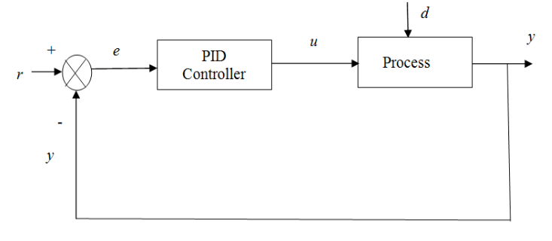

Fig 1 : Block diagram of a close loop control with PID controller

Standard nomenclature for different symbols used in Fig. 1 -

r =set point (the desired value of a controlled variable is referred to as its set point)

y=process output (controlled variables)

e=error signal

u=controller output

d=disturbance

Here, Our goal is to align the controlled variable y with its set point r. The block diagram illustrates the discrete form of a conventional PID controller, as depicted in Figure 2. Central to achieving the desired control performance are three adjustable gain parameters: proportional gain (Kp), integral gain (Ki), and derivative gain (Kd). These parameters play a crucial role in fine-tuning the controller to effectively regulate the system and bring the controlled variable to the specified set point.

Output of the controller can be expressed as:

                                  uc(k) = Kp [ek+ (∆t/Ti) ∑ e(i)+ (Td/∆t)∆e(k) ]

or

uc(k)=Kp [ek + Ki*∑e(i) + Kd*∆e(k)

Where, Kp is the proportional gain, where Ki= Kp(∆t/Ti) and Kd= Kp(Td/∆t) are the integral and derivative gains, respectively. Ti represents the integral time, Td is the derivative time, and ∆t is the sampling time period. The critical task at hand is the proper selection of these three tuning parameters—Kp, Ti, and Td—to achieve the desired close-loop performance efficiently.

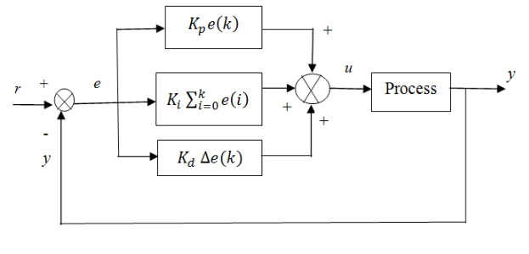

Fig 2 : Parallel form of PID controller and process

Over the years, numerous methods have been devised to tune PID parameters, with the Ziegler-Nichols (ZN) continuous cycling method standing out as the most commonly employed approach by practitioners for the initial PID parameter settings. Alternatively, metaheuristic techniques such as TLBO, PSO, GA, and others can be utilized to fine-tune these parameters via minimizing the error, representing the difference between the setpoint and the actual system response. The error can be quantified through metrics such as integral-absolute-error (IAE), integral-time-absolute-error (ITAE), or a combination of both (IAE+ITAE).

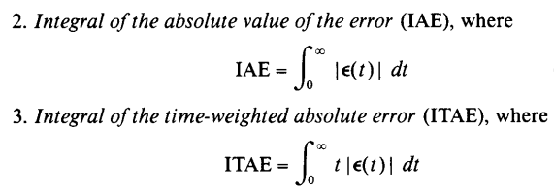

Here we have considered the following 2nd order process control transfer function with dead time L :

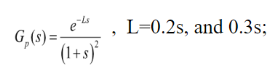

Y(s)

U(s)

Process

$$\frac{Y\left(s\right)}{U\left(s\right)}=\frac{e^{-0.2s}}{{\left(1+s\right)}^{2}}$$

$=> Y\left(s\right)*{\left(1+s\right)}^{2}=U\left(s\right)*e^{-0.2s}$

${=>s}^{2}*Y\left(s\right)+2*s*Y\left(s\right)+Y\left(s\right)=U\left(s\right)*e^{-0.2s}$

Time domain

$$\frac{d\left(\frac{dy}{dt}\right)}{dt}+2*\frac{dy}{dt}+y\left(t\right)=u(t-0.2)$$

$=> \frac{dx}{dt}+2*x+y(t)= u(t-0.2)$, $x=\frac{dy}{dt}$

F_xy = @(u, y, x) $u – 2*x - y$ (Matlab function)

Again,

$$\frac{dy}{dx}=x$$

$=> y\left(i+1\right)=y\left(i\right)+h*x$

We have used 4th order runge kutta method to evaluate $\frac{dx}{dt}$.

Zigler-Nichol’s Ultimate Cycle Method:

The ultimate cycle method involves a systematic procedure for determining critical parameters in the tuning of a proportional controller. In the first step, integral and derivative actions are eliminated by setting Td to zero and Ti to the maximum feasible value after the process has attained steady state. Following this, the proportional gain, Kp, is set to a small initial value. A minor, momentary set-point change is then introduced to induce deviation from the set point, and Kp is gradually increased in incremental steps until a continuous cycle ensues. Continuous cycling, characterized by sustained oscillation with a constant amplitude, is a key indicator. The numerical value of Kp at which continuous cycling occurs is defined as the ultimate gain, Kcu. Additionally, the period of the sustained oscillation is denoted as the ultimate period, Tu. This method serves as a practical approach to identify critical parameters for effective proportional-only control tuning.

We can find the the PID controller values using Ziegler-Nichols (Z-N) tuning parameters in the Table below :

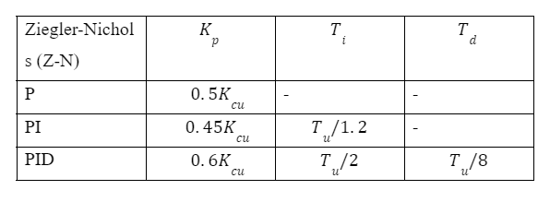

Table : Controller setting based on the continuous cycling method

its model free approach, *i*.*e*., prior to the tuning no model is required for the process for which the controller is to be tuned.

**Minimizing Error using PSO :**

Objective function, f = IAE + ITAE

  


|  |  |
| --- | --- |
| Population Size | 5 |
| Decision Variables | Kp, Ki, Kd |
| Upper Bound | 10.5, 2.033, 2.033 |
| Lower Bound | 0, 0, 0 |

Upper Bound : Maximum possible value according to Zigler-Nichols tuning.

**Result :**

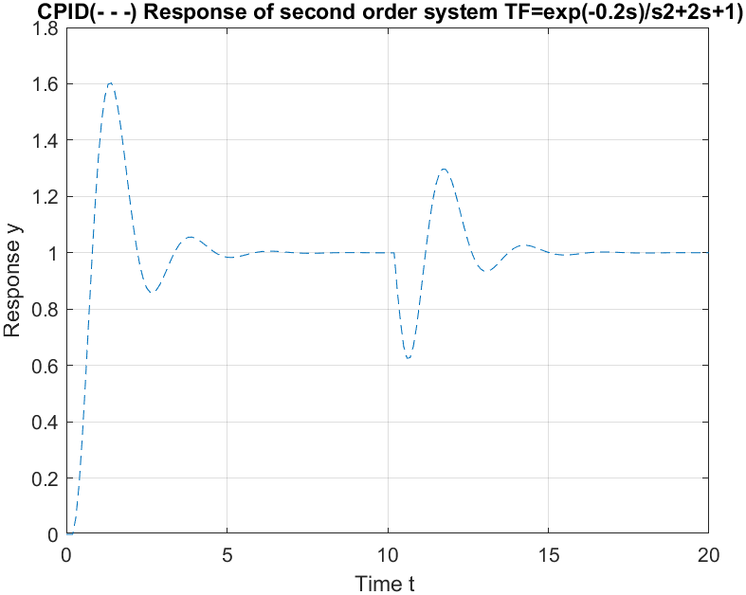

Fig-3 : Output curve for Zigler Nichols Tuning

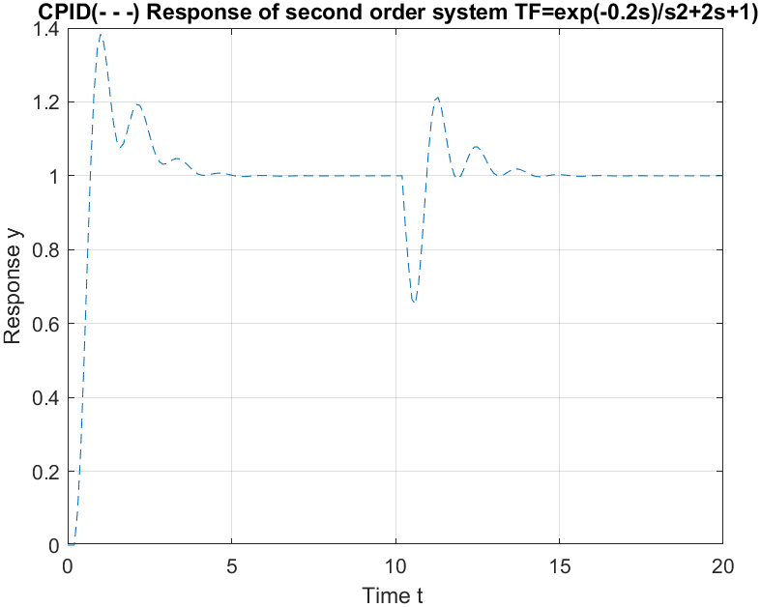

Fig-4 : Output Curve for minimizing error using PSO

|  |  |  |  |  |  |  |
| --- | --- | --- | --- | --- | --- | --- |
| Controller | Minimization function | %OS | Tr | Ts | IAE | ITAE |
| CPID | IAE + ITAE | 60% | 1.4 | 6 | 1.85 | 8.24 |
| PSO-CPID | IAE + ITAE | 38% | 1 | 5.2 | 1.27 | 4.66 |

If we compare both the results :

**Conclusion and Further Scope :**

In our study, we conducted a comprehensive comparison of closed-loop response characteristics for a given process model using PID controllers tuned through Ziegler-Nichols (Z-N) tuning and performance-based tuning with Particle Swarm Optimization (PSO). Alongside response characteristics, various performance indices—such as **percentage overshoot** (%OS), **rise time** (Tr), **settling time** (Ts), integral absolute error (IAE), and integral time absolute error (ITAE)—were calculated for each controller.

The PSO-CPID controller outperformed the CPID controller, particularly when compared to controllers tuned using Z-N tuning. The utilization of Ziegler-Nichols-based continuous cycling method for tuning relations, chosen for its widespread acceptance and simple relational expression, facilitated this comparative analysis. The promising results from PSO-CPID suggest its potential for optimizing the performance of more advanced controllers, including adaptive PID controllers, opening avenues for further improvements in controller design and application.

Top of Form